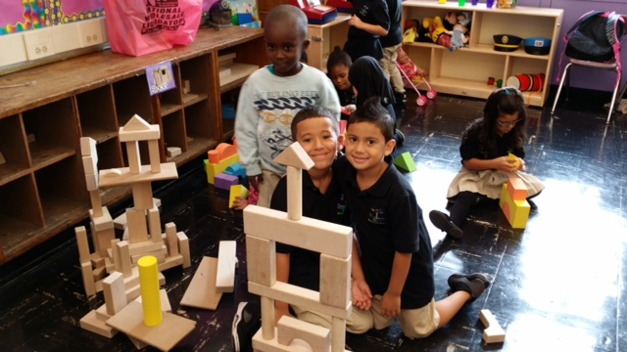

September 2014

We Learned About…

Kindergarten News

**October Homework Project…**

**We have special visitors in our class…**

**Each night one of our teddy friends will visit a different child’s home. Please write about what you and Teddy did at home and send the bear and his suitcase back the following day.**

**Math Project:** Numbers in Our neighborhood

**Due: Oct 20, 2014**

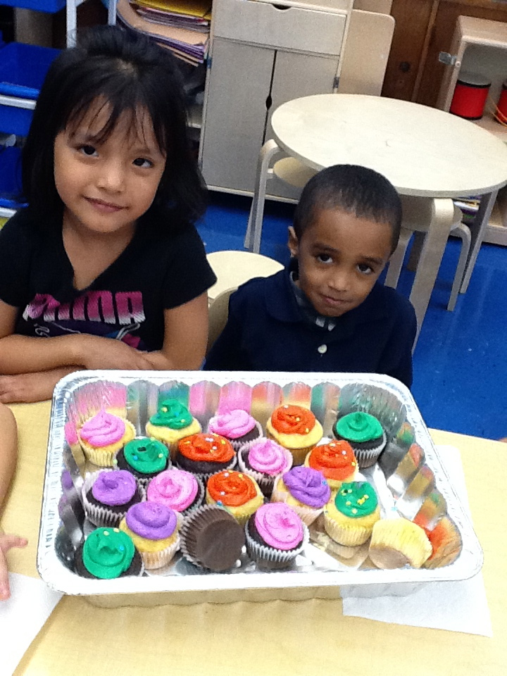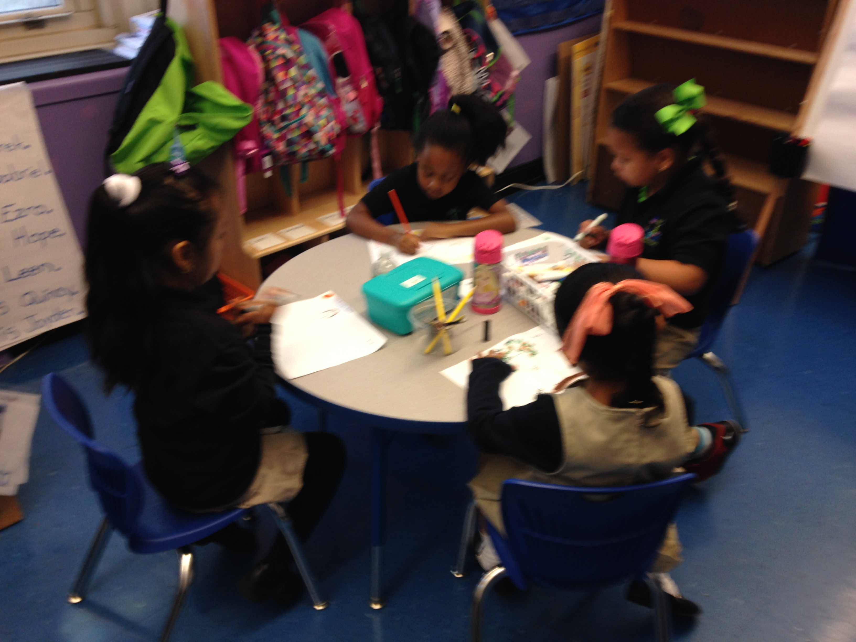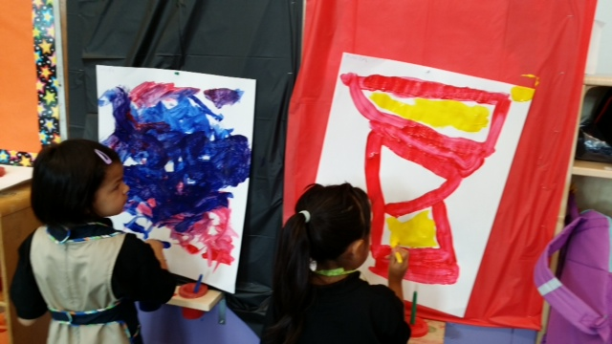

September

Birthdays

Ayaan Sept 15

Jenise Sept 22

Jueleen Sept,28

Eudaldo,Sept,9

Katie,Sept,20

October Birthdays

Our Party will be October 17 at 1:15pm

If you want to organize a party in your classroom please contact class parents.

David Oct. 1

Papadome Oct. 4

Joseph Oct. 13

Johansel Oct. 29

Hope Oct 2

Isabella October 5

Derek October 18

Ayah October 21

Natasha October 23

Kewin October,19

Shamuel Oct 5

Ourselves

Summer Trees

Learning

Welcome to Kindergarten…

Welcome families to our Linden Tree community. We are so excited to be beginning our year and we are already very busy. We are beginning to learn how to read and write by using pictures to understand and tell stories. Please encourage your child to read picture books and draw each night. We also had some beary special visitors to our class…we can’t wait to see what they will do next. During the month of October we will be learning about Fall Trees, Our Families and how to be and Investigator. Be sure to keep an eye out for some special homework that will be coming home in the next few weeks.

We are writing stories by…

Drawing pictures

Listening to sounds and writing letters

Telling our stories to our friends

### Math Skills of the Month…

### Sorting

### Counting to 5

### Writing the numbers to 5

### Reading Skills of the Month…

### Reading our names

### Rhyming

### Syllables

### Listening to stories

### Pointing to words

Our Learning Leaders Are…

Jayden

Javien

Isabella

Kayla

Katie

Tamim

Joseph

Karen