Table of Contents
GRADE K • MODULE 2
Two-Dimensional and Three-Dimensional Shapes

Module Overview i

Topic A: Two-Dimensional Flat Shapes 2.A.1

Topic B: Three-Dimensional Solid Shapes 2.B.1

Topic C: Two-Dimensional and Three-Dimensional Shapes 2.C.1
Module Assessment 2.S.1

Grade K • Module 2
Two-Dimensional and Three-Dimensional Shapes

OVERVIEW
In Module 1, students began the year observing their world. What is exactly the same? What is the same but…? They matched and sorted according to criteria sequenced from simple to complex. Their perceptions evolved into observations about numbers to 10. “4 is missing 1 to make 5.” “4 plus 1 more is 5.” “There are the same number of dogs and flowers, 6!”
In this module, students seek out flat and solid shapes in their world (K.G.1). Empowered by this lens, they begin to make connections between the wheel of a bicycle, the moon, and the top of an ice cream cone. Just as the number 4 allowed them to quantify 4 mountains and 4 mice as equal numbers, learning to identify flats and solids allows them to see the relationship of the simple to the complex, a mountain’s top to a plastic triangle and cone sitting on their desk.
To open Topic A, students find and name shapes in their environment using informal language, describing flat shapes without naming them (K.G.4). In Lesson 2, they classify the shapes, juxtaposing them with various examples and non-examples. This process further refines their ability to talk about the shapes, for example, as closed or having straight sides. The naming of the flat shape as a triangle or hexagon is part of that process, not the focus of it (K.G.2, K.G.1).
The same process is then repeated with rectangles in Lesson 3 and hexagons and circles in Lesson 4. In Lesson 5, students manipulate all the flat shapes using position words as the teacher gives directives such as, “Move the closed shape with three straight sides behind the shape with six straight sides.” These positioning words are subsequently woven into the instructional program, at times in math fluency activities, but also throughout the entire school day.
The lessons of Topic B replicate those of Topic A but with solid shapes. In addition, students recognize the presence of the flats within the solids. The module closes in Topic C with discrimination between flats and solids. A culminating task involves students in creating displays of a given flat shape with counter-examples and show related solid shapes (K.G.3).
The fluency components in the lessons of Module 1 included activities wherein students used a variety of triangles and rectangles to practice the decompositions of 3 and 4. Flats and solids will continue to be included in fluency activities in this module, and throughout the year so that students have repeated experiences with shapes, their attributes, and their names. Daily number fluency practice in this new module is critical. There are two main goals of consistent fluency practice: (1) to solidify the numbers of Module 1 and (2) to anticipate the numbers of Modules 3, 4, and 5. Therefore, students continue to work extensively with numbers to 10 and fluency with addition and subtraction to 5.
The kindergarten year closes in Module 6 with another geometry unit. By that time having become much more familiar with flats and solids, the students compose new flat shapes (“Can you make a rectangle from these two triangles?”) and build solid shapes from components (“Let’s use these straws to be the edges and these balls of clay to be the corners of a cube!”). This module will allow them to bring together all that they have learned throughout the year as they manipulate shapes and their components (K.G.4 and K.G.5).
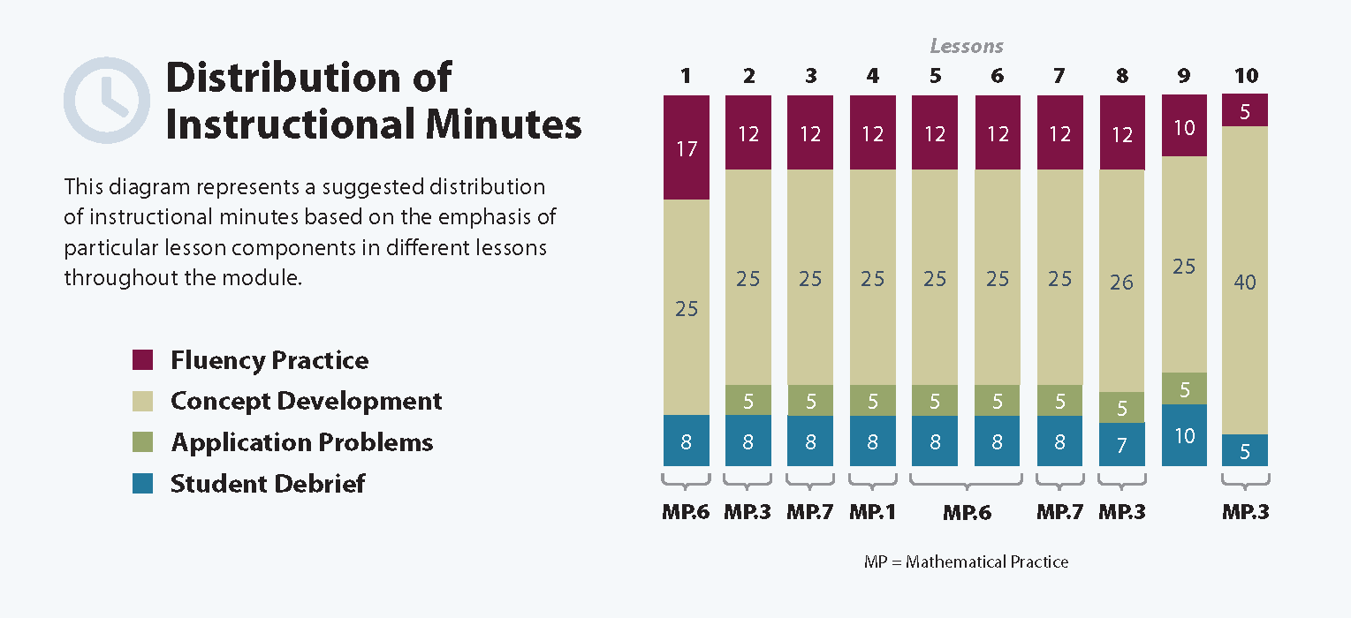

Focus Grade Level Standards
Classify objects and count the number of objects in each category.
K.MD.3 Classify objects into given categories; count the numbers of objects in each category and sort the categories by count. (Limit category counts to be less than or equal to 10.)
Identify and describe shapes (squares, circles, triangles, rectangles, hexagons, cubes, cones, cylinders, and spheres).
K.G.1 Describe objects in the environment using names of shapes, and describe the relative positions of these objects using terms such as above, below, beside, in front of, behind, and next to.
K.G.2 Correctly name shapes regardless of their orientations or overall size.
K.G.3 Identify shapes as two-dimensional (lying in a plane, “flat”) or three-dimensional (“solid”).
Analyze, compare, create, and compose shapes.
K.G.4 Analyze and compare two- and three-dimensional shapes, in different sizes and orientations, using informal language to describe their similarities, differences, parts (e.g., number of sides and vertices/”corners”) and other attributes (e.g., having sides of equal length).
Foundational Standards
Identify and describe shapes (squares, circles, triangles, rectangles).
PK.G.1 Describe objects in the environment using names of shapes, and describe the relative positions of these objects using terms such as top, bottom, up, down, in front of, behind, over, under, and next to.
PK.G.2 Correctly name shapes regardless of size.
Analyze, compare, and sort objects.
PK.G.3 Analyze, compare, and sort two- and three-dimensional shapes and objects, in different sizes, using informal language to describe their similarities, differences, and other attributes (e.g., color, size, and shape).
PK.G.4 Create and build shapes from components (e.g., sticks and clay balls).
Focus Standards for Mathematical Practice
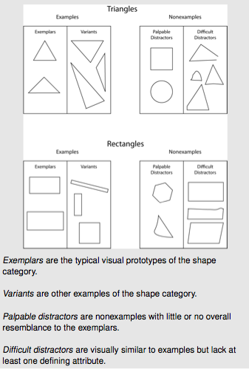
MP.1 Make sense of problems and persevere in solving them. Students distinguish shapes from among variants, palpable distractors, and difficult distractors. (See examples to the right).
MP.3 Construct viable arguments and critique the reasoning of others. Students are increasingly able to use shape attributes to defend identification of a plane or solid shape.
MP.6 Attend to precision. Students use position words to clearly indicate the location of shapes. Also, when kindergarten students are analyzing and defining attributes such as “3 straight sides” they are attending to precision.
MP.7 Look for and make use of structure. Students use examples, non-examples, and shared attributes of geometric figures in order to develop a richer concept image (Geometry Progressions, p. 6) of each geometric shape. This concept image allows for more acute discernment of the shape within the environment.

Overview of Module Topics and Lesson Objectives
Standards | Topics and Objectives |  | Lesson Activity | Assessment
K.G.1  K.G.2  K.G.4  K.MD.3 | A | Two-Dimensional Flat Shapes  Lesson 1: Find and describe flat triangles, squares, rectangles, hexagons, and circles using informal language without naming.  Lesson 2: Explain decisions about classifications of triangles into categories using variants and non-examples. Identify shapes as triangles.  Lesson 3: Explain decisions about classifications of rectangles into categories using variants and non-examples. Identify shapes as rectangles.  Lesson 4: Explain decisions about classifications of hexagons and circles, and identify them by name. Make observations using variants and non-examples.  Lesson 5: Describe and communicate positions of all flat shapes using the words above, below, beside, in front of, next to, and behind. | Students will look at shapes in groups and describe orally  Students will look at different triangles in groups and describe orally what is and is not a triangle  Students will look at different rectangles in groups and describe orally what is and is not a rectangle  Students will look at different hexagons in groups and describe orally what is and is not a hexagon  Students will be introduced to the concepts of above, below, beside, in front of, next to, and behind with people  Introduce Big Idea question: Are there little shapes inside of big shapes. | Shapes page in journal  Page in journal  Page in journal  Page in journal  Page in Journal and fllowing directions to cut and paste  Class chart of findings
K.G.1  K.G.2  K.G.4  K.MD.3 | B | Three-Dimensional Solid Shapes  Lesson 6: Find and describe solid shapes using informal language without naming.  Lesson 7:  Monday Feb 2 Explain decisions about classification of solid shapes into categories. Name the solid shapes. | Students will look at solid shapes and describe solid shapes in groups by naming the shapes inside the solid and whether it slides or rolls  Naming the solid students will discuss the name of the solid and the how they know it is that solid…make a solid with clay and describe the shape | Draw and describe your shape…add to the chart does it slide or roll  Math journal  Can students name and describe soild shapes
K.MD.3  K.G.3  K.G.4  K.G.1  K.G.2 | C | Two-Dimensional and Three-Dimensional Shapes  Lesson 9:  Tuesday Feb 3 Identify and sort shapes as two-dimensional or three-dimensional, and recognize two-dimensional and three-dimensional shapes in different orientations and sizes.  Lesson 10:  Wednesday  Feb 3/4 Culminating task—collaborative groups create displays of different flat shapes with examples, non-examples, and a corresponding solid shape.  Lesson 8:  Friday Feb 5 Describe and communicate positions of all solid shapes using the words above, below, beside, in front of, next to, and behind. | With a variety of 2 D and 3 d shapes on desk students will sort 2 d and 3 d shapes on sorting mat  Day 1  Students will explore and recreate, and describe how their shape looks.  Day 2: Students will describe, properties of their shape to create a shape display.  Students will use the words below, beside, in front of, next to, and behind assign shapes on the carpet around an object | Students will get a shape and will teach others about their shape by…  Recreating their shape  describing their shape by expressing how many sides and how many corners.  Finding examples of their shape  And describing whether there are any shapes hiding inside of their shape.  Journal Page
 |  | End-of-Module Assessment: Topics A–C (Interview style assessment: 2 days)
Total Number of Instructional Days

Terminology
New or Recently Introduced Terms
- Above, below, beside, in front of, next to, behind (position words)
- Circle
- Cone (solid shape)
- Cube (solid shape)
- Cylinder (solid shape)
- Face (flat side of a solid)
- Flat (two-dimensional shape)
- Hexagon (flat figure enclosed by six straight sides)
- Rectangle (flat figure enclosed by four straight sides)
- Solid (three-dimensional shape)
- Sphere (solid shape)
- Square (flat figure enclosed by four straight, equal sides)
- Triangle (flat figure enclosed by three straight sides)
Familiar Terms and Symbols
- Match (group items that are the same or have the same given attribute)
- Sort
Suggested Tools and Representations
- Three-dimensional shapes: cone, sphere, cylinder, and cube
- Two-dimensional shapes: circle, hexagon, rectangle, square, and triangle

Scaffolds
The scaffolds integrated into A Story of Units give alternatives for how students access information as well as express and demonstrate their learning. Strategically placed margin notes are provided within each lesson, elaborating on the use of specific scaffolds at applicable times. They address many needs presented by English language learners, students with disabilities, students performing above grade level, and students performing below grade level. Many of the suggestions are organized by Universal Design for Learning (UDL) principles and are applicable to more than one population. To read more about the approach to differentiated instruction in A Story of Units, please refer to “How to Implement A Story of Units.”
Assessment Summary
Type | Administered | Format | Standards Addressed
End-of-Module Assessment Task | After Topic C | Interview with Rubric | K.MD.3  K.G.1  K.G.2  K.G.3  K.G.4
Culminating Task | Lesson 10 | Collaborative Project | K.MD.3  K.G.1  K.G.2  K.G.3  K.G.4

The balance of this cluster is addressed in Module 6.
This image plus further clarification is found in Geometry Progressions, p. 6.
In the context of polyhedra, faces must be polygonal. However, in more general contexts, a face may be circular (such as the base of a right circular cylinder), or even irregular. It is this more inclusive interpretation of face that is used in this Kindergarten module.
These are terms and symbols students have seen previously.
Students with disabilities may require Braille, large print, audio, or special digital files. Please visit the website www.p12.nysed.gov/specialed/aim for specific information on how to obtain student materials that satisfy the National Instructional Materials Accessibility Standard (NIMAS) format.

